**Main Success Scenario**

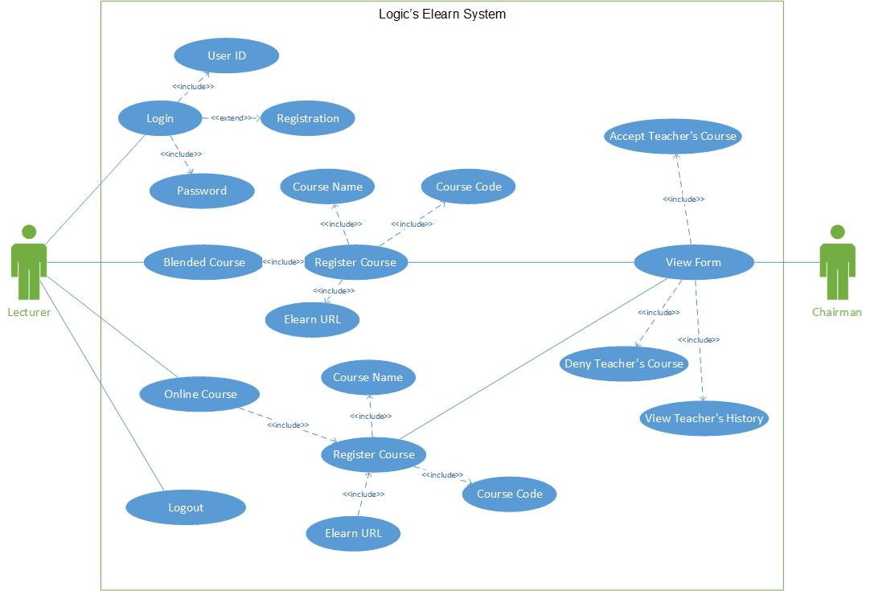

1. The login box pops up. The following fields are available.

* ID
* Password
* Forgot Password
* Register

1. User enters ID and Password to login
2. User select type of course : Blended or Online
3. Register for course for either blended or online. The following fields are available when registering a   course.

* Course Name
* Course Code
* Elearn URL

1. User can logout or go back to Homepage to add more courses.
2. Course that has been registered is added to a form that is sent to the chairman.
3. Chairman views form.

Extensions (Additional Scenarios or exceptions)

1A) New users to the application.

1a1) New users that never logged into the site before has to Register.

1a2) Return to Step 2.

6A) Viewing form

6a1) Form is able to view a teacher’s course history.

6a2) Course on form can be accepted or denied by chairman.